- The first UK economic data and surveys released in 2024 suggest that the economy gained some momentum at the end of last year. December's composite PMI rose to a six-month high, while mortgage demand and unsecured lending picked up in November.
- Evidence of easing price pressures in the BoE's latest business survey was another positive. But the survey also pointed to continued stickiness in wages growth, as did December's S&P Global/CIPS services survey. This supports our view that the BoE is unlikely to begin cutting interest rates until May, by which time it should be satisfied pay growth is on a downward trend.
Evidence on the economy's performance released in the first week of the new year suggests momentum picked up at the tail-end of 2023. Granted, December's manufacturing PMI slipped to 46.2 from 47.2 the previous month and the construction PMI also remained below the 50 'no-change' mark, if rising a little from November. But from a whole-economy perspective, a strong rise in the services PMI to a six-month high of 53.4 (November: 50.9) more than compensated. This lifted the composite PMI to 52.1, the second successive month in expansionary, 50-plus, territory and the strongest outturn since last June (Chart 1).
For sure, since the PMIs exclude the retail and public sectors, they give an incomplete picture of the economy. These other sectors have had contrasting fortunes of late – retail should have been boosted by falling inflation, but NHS strikes in December will have weighed on public sector output. Next week's GDP release for November should give a decent steer, but given the economy's poor start to Q4, any growth in the final quarter of 2023 is likely to have been marginal.
That said, signs of a revival in lending demand offer an upside risk. Aided by falling quoted mortgage rates over much of the second half of 2023, mortgage approvals rose to 50,067 in November from October's 47,888, the highest level in six months. Nonetheless, this was still 24% below the level in (pre-Covid) November 2019. Net mortgage lending flatlined, a lagged effect of a fall in approvals last summer. However, net unsecured lending jumped to £2bn in November, the highest level in almost seven years.
Chart 1: A rise in the PMI has reduced the odds that the economy shrank in Q4 2023
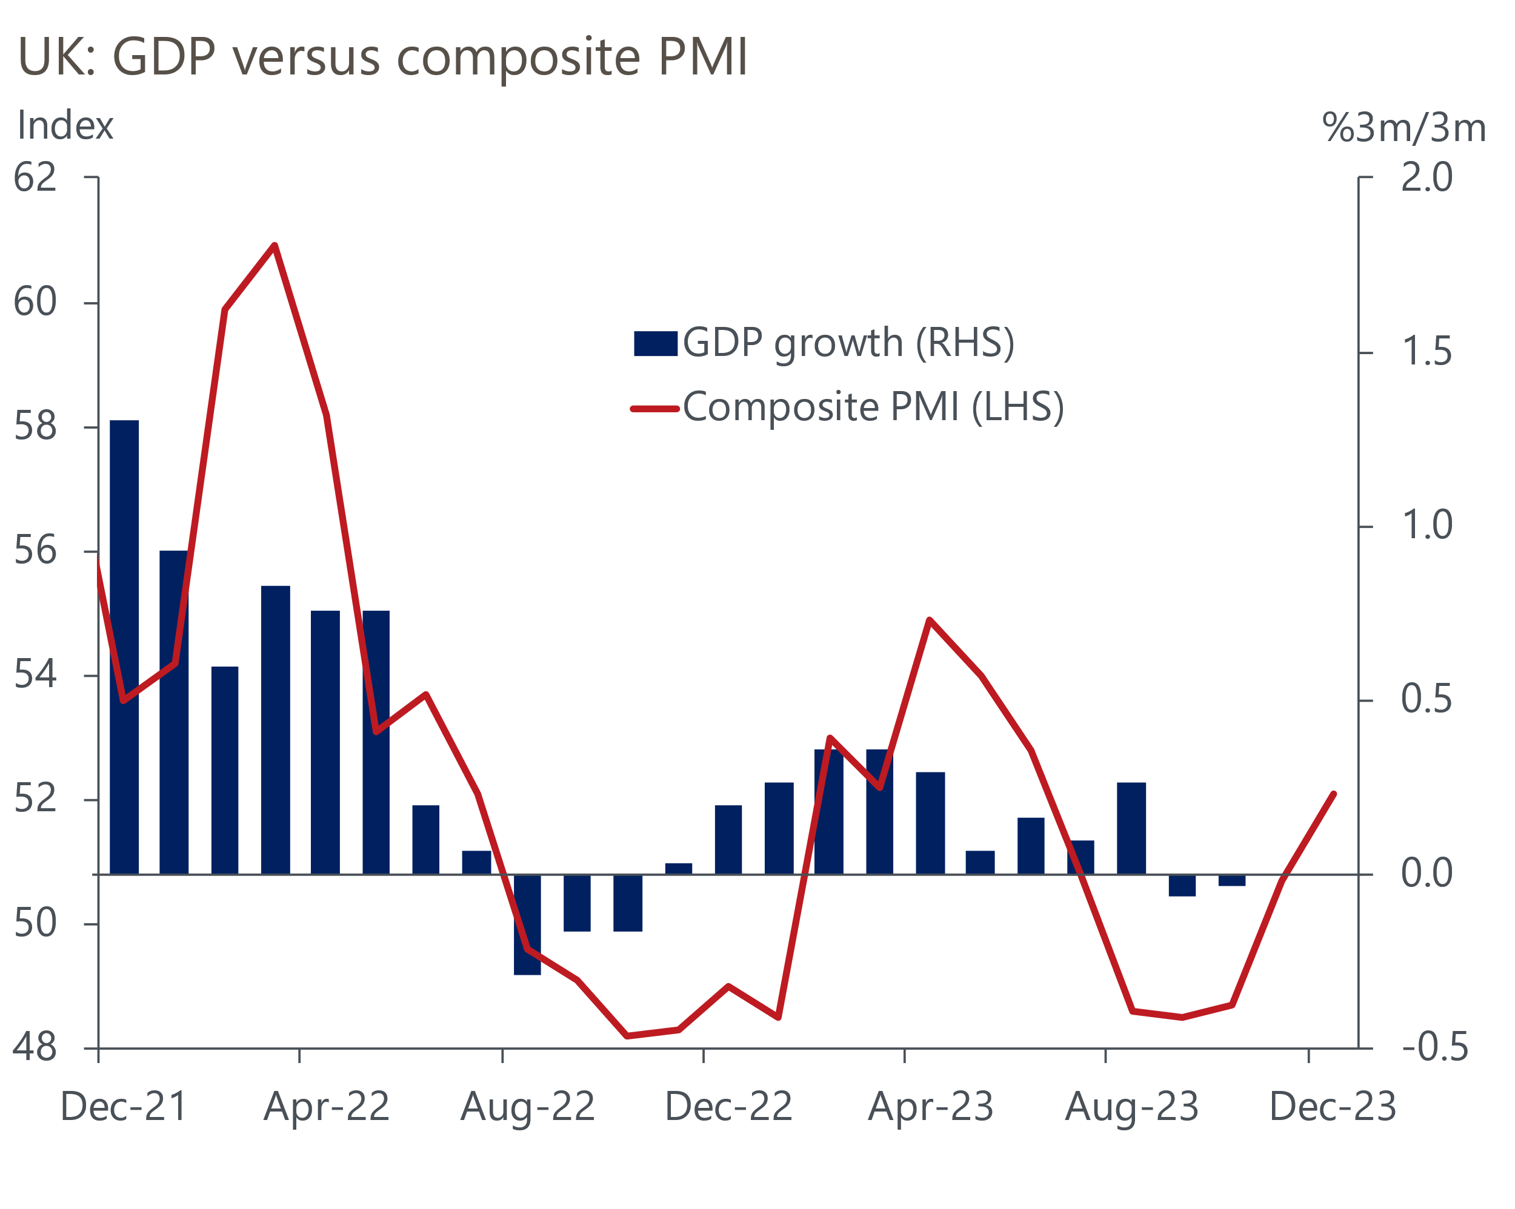
Source: Oxford Economics/S&P Global/CIPS

Meanwhile, a 1.1% m/m rise in Halifax's measure of house prices in December suggested that resilience in property values in late 2023 continued. With Nationwide's index showing values unchanged in the same month, an average of the two measures was slightly higher in December than last January, if just over 3% lower than the peak in autumn 2022.
The last week saw lenders continue to cut rates on new mortgages in response to falling swap rates, as investors have reassessed the timing and scale of a likely loosening in monetary policy by the Bank of England's Monetary Policy Committee. This should support property values and a further recovery in mortgage activity. The big question is whether the MPC will lower Bank Rate as aggressively this year as market pricing, which currently sees the policy rate falling to 4% by December, implies.
On that question, the latest evidence offered something for the doves and the hawks. The BoE's monthly Decision Makers Panel (DMP) survey of corporate CFOs showed expected price growth for the 12 months ahead falling to 4.2% in December, down from nearly 7% in mid-2022. MPC member Catherine Mann has argued that in the past lower expected price growth has not fully translated into declines in the survey's measure of actual price rises. But that seems to be changing – 'realised' price growth in December fell sharply to 4.9%, a 25-month low (Chart 2).
Chart 2: According to the BoE's survey, price rises by firms in the year to December fell sharply
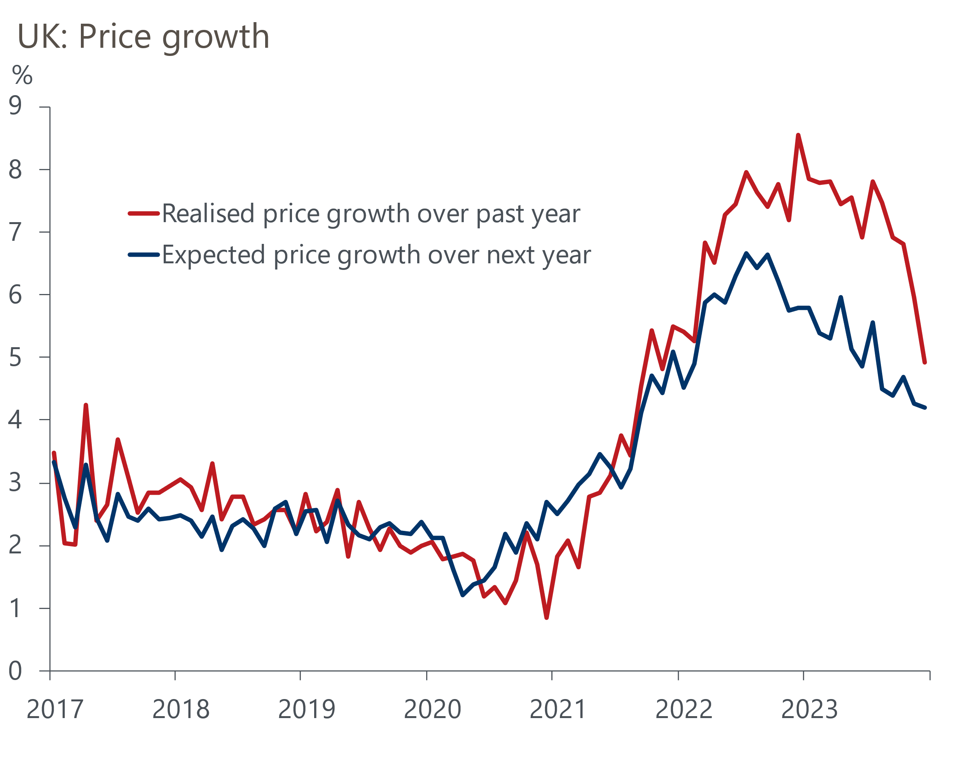
Source: Oxford Economics/Bank of England
The DMP also pointed to continued stickiness in wage growth, one of the MPC's bugbears. Expected pay growth was just over 5% in December, a pace little changed from earlier last year. And realised pay growth was still 7%. Pressure on firms' costs from wage rises was also a feature of the latest CIPS/S&P Global services survey. Strong pay growth contributed to the survey's measure of input price inflation accelerating in December to the highest in four months.
The monetary policy tide has decisively turned over the past month, and the next move in Bank Rate will almost certainly be down. But the MPC's nervousness over the strength of pay growth means that before starting to loosen policy, it is likely to want to see evidence that pay settlements in the early months of the year are coming in much lower than in 2023, particularly given the potential for April's near-10% rise in the national living wage to influence pay awards at the lower end of the income distribution.
Therefore, our new forecast, released next week, will see us as one with markets in expecting the first cut in Bank Rate in May. We forecast a cumulative 100bps of cuts this year, leaving Bank Rate at 4.25% by the end of 2024. This implies a slightly more risk-averse approach from policymakers than current market pricing implies. But it wouldn't be hard to envisage the MPC taking a more aggressive approach, particularly if the pickup in GDP growth that we anticipate will happen during 2024 fails to materialise.

The week ahead
GDP data for November is next week's sole major release. We think the numbers will show the economy rebounded in November following October's 0.3% m/m contraction. Retail sales rose strongly in November and a rise in the composite PMI to 50.7 took the PMI into expansionary territory for the first time since July. Consumer confidence also picked up, while a pause in strikes by NHS workers following industrial action in October should have boosted output from the health sector. We've pencilled in a 0.4% rise in GDP in November.
Table 1: Week ahead calendar
Date | Events | Period | Measure | Unit | Previous | Forecast
Jan 12 | GDP | Nov | m/m | % | -0.3 | 0.4
Jan 12 | GDP | Nov | 3m/3m | % | -0.1 | -0.1
Jan 12 | Index of services | Nov | m/m | % | -0.2 | 0.4
Jan 12 | Index of services | Nov | 3m/3m | % | -0.1 | 0.0
Jan 12 | Manufacturing output | Nov | m/m | % | -1.1 | 1.1
Jan 12 | Manufacturing output | Nov | y/y | % | -0.9 | 2.1
Jan 12 | Industrial production | Nov | m/m | % | -0.8 | 0.6
Jan 12 | Industrial production | Nov | y/y | % | 0.3 | 0.7
Jan 12 | Construction output | Nov | m/m | % | -0.5 | 0.2
Jan 12 | Construction output | Nov | y/y | % | 1.1 | 1.2
Jan 12 | UK trade | Nov | Trade balance | £bn | -4.5 | -2.8
Jan 12 | UK trade | Nov | Visible balance | £bn | -17.0 | -14.2
Source: Oxford Economics

Key forecasts
Table 2: UK forecast overview
(Annual percentage changes unless specified)
 | 2021 | 2022 | 2023 | 2024 | 2025 | 2026
GDP | 8.7 | 4.3 | 0.6 | 0.5 | 1.5 | 1.9
Private consumption | 7.5 | 4.9 | 0.5 | 0.2 | 1.5 | 1.9
Fixed investment | 7.4 | 7.9 | 2.7 | -3.4 | 0.3 | 2.7
Government consumption | 14.9 | 2.5 | 0.3 | 4.4 | 2.1 | 1.6
Exports of goods and services | 4.9 | 8.6 | -0.4 | 2.0 | 2.8 | 2.2
Imports of goods and services | 6.1 | 14.1 | -0.8 | 3.6 | 2.7 | 2.5
Industrial Production | -3.9 | -3.5 | -0.1 | 0.0 | 0.8 | 1.5
Consumer prices | 2.6 | 9.1 | 7.4 | 3.2 | 1.6 | 1.6
Unemployment rate (%) | 4.5 | 3.7 | 4.2 | 4.5 | 4.4 | 4.1
Current a/c balance (% of GDP) | -0.5 | -3.2 | -2.7 | -2.8 | -2.7 | -2.7
Government balance (% of GDP) | 7.2 | 4.3 | 5.2 | 3.2 | 2.7 | 2.1
Cen. bank policy rate (%, EOP) | 0.25 | 3.50 | 5.25 | 4.75 | 3.75 | 2.75
10yr govt. bond yield (%, EOP) | 0.97 | 3.67 | 4.05 | 3.97 | 3.71 | 3.22
Exchange rate (US$ per £, EOP) | 1.35 | 1.20 | 1.26 | 1.26 | 1.28 | 1.32
Exchange rate (euro per £, EOP) | 1.19 | 1.13 | 1.17 | 1.16 | 1.15 | 1.15
Source: Oxford Economics
Table 3: Quarterly forecasts for the UK
 | 2023 |  |  |  | 2024
 | Q1 | Q2 | Q3 | Q4 | Q1 | Q2 | Q3 | Q4
GDP (% year) | 0.5 | 0.6 | 0.6 | 0.7 | 0.4 | 0.3 | 0.5 | 0.6
CPI inflation (% year) | 10.2 | 8.4 | 6.7 | 4.3 | 4.1 | 3.0 | 3.1 | 2.7
Bank Rate (%, EOP) | 4.25 | 5.00 | 5.25 | 5.25 | 5.25 | 5.25 | 5.00 | 4.75
10yr gilt yield (%, EOP) | 3.47 | 4.39 | 4.46 | 4.05 | 4.05 | 4.04 | 4.01 | 3.97
US$ per £ (EOP) | 1.24 | 1.27 | 1.22 | 1.26 | 1.26 | 1.26 | 1.26 | 1.26
Euro per £ (EOP) | 1.14 | 1.17 | 1.15 | 1.17 | 1.16 | 1.16 | 1.16 | 1.16
Source: Oxford Economics

Latest Country Economic Forecast:
December 11, 2023

Recent publications

Data Insights
Services PMI suggests the sector ended 2023 on a high
More signs of life in the housing market
Manufacturing sector ended 2023 on a weak footing
National accounts paint a weaker picture for 2023
Growth in retail sales returned in November

Research Briefings
Rethinking QE in light of large asset purchase losses
Nowcast suggests wage momentum continues to cool
BoE continues to push back on hopes of near-term rate cuts
MPC preview – Another hawkish hold
Key themes 2024 – Tight policy settings weigh on growth

Contacts

Oxford Economics' UK team
- Andrew Goodwin - Chief UK Economist - agoodwin@oxfordeconomics.com
- Edward Allenby - UK Economist - eallenby@oxfordeconomics.com

